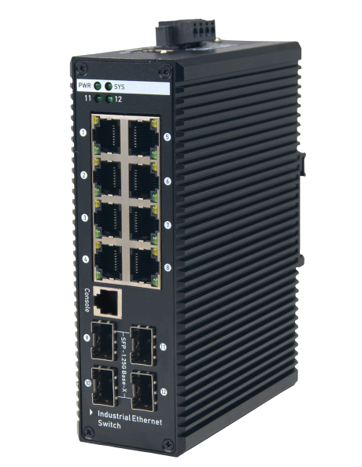
SP5200-4PFE2FE

HanXin Industrial POE Switch
Surge Protection Design
provides contact discharge of ±8KV DC and air discharge of ±15KV DC for Ethernet ESD protection. It also supports ±6KV surge immunity to improve product stability and protects users’ networks from devastating ESD attacks, making sure the flow of operation does not fluctuate.
SP5200-4PFE2FE
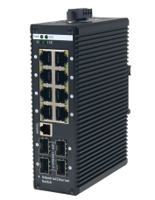
Model:HX2208-4SFP
Key Features:
Ports: Provide 8*10/100/1000Mbps PoE ports with 4 1000Mbps SFP
PoE Standard: IEEE802.3af/at Power over Ethernet (PoE) Compliant
Self-adaption: RJ45 port supports 10/100/1000Mbps Auto MDI/MDIX
Industrial Installation: Din Rail mounting installation
Wide Application: Designed for Railway, traffic etc some Industrial environment
Surge protection: Protect the device from lighting surges and others electrical hazards
Managed: Support remote web managed,VLAN and storm control and IPV6 management etc.
Working Temperature: -40 to 85 degrees operating temperature
Considerate Design: IP40 Industrial design with dual power input
Easy to use: Plug and play, No configuration required

Environmentally Hardened Design
With the IP40 metal industrial case which provides a high level of immunity against electromagnetic interference and heavy electrical surges,Being able to operate under the temperature range from -40 to 85 degrees C, the HX2208-4SFP can be placed in almost any difficult environment.
Gigabit SFP Uplink Port
With two SFP module slot available, the SFP uplink port is ideal for connecting the switch to the network’s backbone, providing more than enough bandwidth and stability for ultra high speed data transferring, Beside the SFP can transmitte the date with Max 100Km distance with more economic solution
Cost-effective IPv6 Managed Gigabit PoE Switch Solution
With layer 2+ managed Gigabit PoE Switch, It provides IPv6/IPv4 management and built-in L2/L4 Gigabit Switching engine, and supports high-speed transmission of surveillance images and videos.
HX2208-4SFP
8-Port 10/100/1000Mbps Industrial Managed PoE Switch with 4 SFP

Model | HX2208-4SFP
Hardware Specifications
Connector | 8 10/100/1000BASE-T RJ45 auto MDI/MDIX ports  4 1000 Base-X SFP Slots 1 Console port
PoE Port | 8 10/100/1000Mbps POE PSE port
LED Display | Power Indicator: PWR(green).  Network Indicator: Link(yellow)  PoE Working Indicator: PoE(green)
Thermal Fan | Fanless Design
Installation | Din Rail
Switch Architecture | Store and Forward
Transmission model | IEEE802.3X full-duplex and Backpressure half-duplex
Switch Performance | Backplane bandwidth | 32Gbps
 | Packet forwarding rate | 19.86Mpps
 | MAC address | 8k
Power requirement | DC 44V~56V
ESD Protection | 6KV ESD
Dimension(W×D×H) | 48mm x 110mm x 150mm(1.89in x 4.33in x 5.91in)
Weight | 1.25kg
Power over Ethernet (PoE) Specifications
Network standard | IEEE802.3i 10 BASE-T  IEEE802.3u 100 BASE-TX  IEEE802.3ab 1000BASE-T  IEEE802.3x Flow Control  IEEE802.3af Power over Ethernet  IEEE802.3at Power over Ethernet  IEEE802.3az EEE
PoE Standard | IEEE 802.3af Power over Ethernet/PSE  IEEE 802.3at Power over Ethernet Plus/PSE
PoE Supply Type | 1/2(+), 3/6(-) End-span
PoE Power Output | Per Port 52V DC, 300mA. max. 15.4 watts (IEEE 802.3af)  Per Port 52V DC, 600mA. max. 30 watts (IEEE 802.3at)
PoE Power budget | 240W optional
Layer 2 Functions
Port Mirroring | TX / RX / both Many-to-1 monitor
Vlan | 802.1Q tagged-based VLAN  Up to 256 VLAN groups, out of 4094 VLAN IDs  802.1ad Q-in-Q tunneling  Voice VLAN;Protocol VLAN;Private VLAN (Protected port),GVRP
Link Aggregation | IEEE 802.3ad LACP and static trunk  Supports 8 groups of 8-port trunk
Spanning Tree Protocol | STP, IEEE 802.1D Spanning Tree Protocol  RSTP, IEEE 802.1w Rapid Spanning Tree Protocol  MSTP, IEEE 802.1s Multiple Spanning Tree Protocol
IGMP Snooping | IGMP (v2/v3) snooping  IGMP querier  Up to 256 multicast groups
MLD Snooping | MLD (v1/v2) snooping, up to 256 multicast groups
Access Control List | IPv4/IPv6 IP-based ACL / MAC-based ACL
PoE Management | Open or close port  Standard POE scheduling management Power and current display  Automatic restarting function of equipment dead machine Timing  Support IP bindings restarting
QoS | 8 mapping ID to 8 level priority queues  --- Port number  --- 802.1p priority  --- 802.1Q VLAN tag  --- DSCP field in IP packet  Traffic classification based, strict priority and WRR
Security | IEEE 802.1X port-based authentication  Built-in RADIUS client to co-operate with RADIUS server  RADIUS / TACACS+ user access authentication  IP-MAC port binding  MAC filtering  Static MAC address  DHCP Snooping and DHCP Option82  STP BPDU guard, BPDU filtering and BPDU forwarding  DoS attack prevention  ARP inspection  IP source guard
Management Function
Basic Management Interfaces | Web browser / Telnet / SNMP v1, v2c, V3  Firmware upgrade by HTTP / TFTP protocol through Ethernet network  Remote / Local Syslog,System log,LLDP protocol ,SNTP
Secure Management Interfaces | SSH, SSL, SNMP
SNMP MIBs | RFC 1213 MIB-II  RFC 1215 Generic Traps  RFC 1493 Bridge MIB  RFC 2674 Bridge MIB Extensions  RFC 2737 Entity MIB (Version 2)  RFC 2819 RMON (1, 2, 3, 9)  RFC 2863 Interface Group MIB  RFC 3635 Ethernet-like MIB
Environment
Safety | FCC Part15 Class A,CE.RoHs
Environment specification | Operating temperature: -40℃~85℃，operating humidity: 5％~95％
 | Storage temperature: -40℃~85℃，storage humidity: 5％~95％

HX2208-4SFP
8-Port 10/100/1000Mbps Industrial Switch with 4 SFP

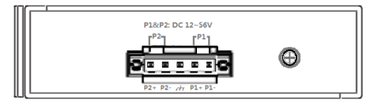
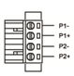
Ground screw
Earth Protection
- 4-pin 3.81mm-spacing plug-in terminal
- 44V-56VDC wide voltage input
- P1&P2 dual power input
- Reverse protection
Power Terminal
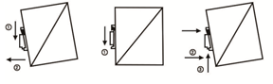
Din-Rail
Mechanical Drawing
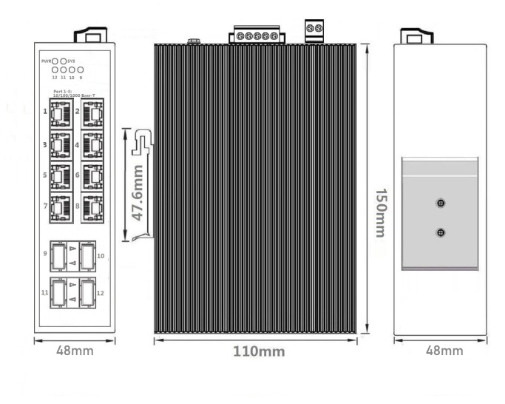
Applications

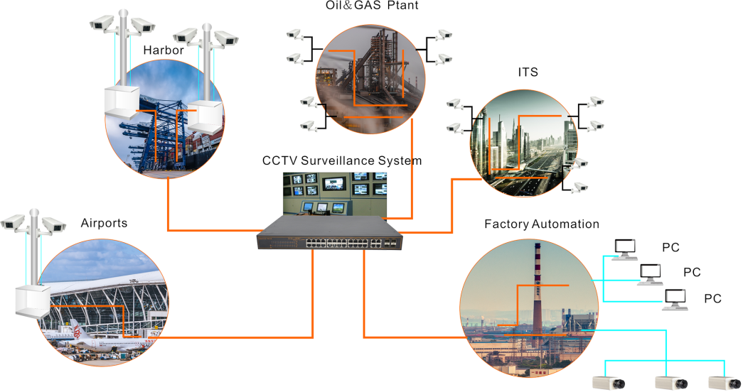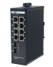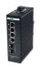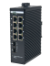

Ordering Information
HX2208-4SFP | 8 Ports 10/100/1000Mbps Industrial Managed PoE switch With 4 SFP
Room 3A21-3A26, Block G5, No.39,Ruihe Road,Huangpu District ,Guangzhou City,Guangdong,510530
www.hansuntel.com Tel:+86-20-31801812 Email: sales@hansun.com.cn

